**A REPORT ON**

**AUTOMATED MONITORING OF WATER**

**SUBMITTED TO THE SAVITRIBAI PHULE PUNE UNIVERSITY, PUNE IN THE PARTIAL FULFILLMENT OF THE REQUIREMENT FOR**

**PROJECT BASED LEARNING (FIRST YEAR ENGINEERING)**

**SAVITRIBAI PHULE PUNE UNIVERSITY, PUNE**



**Department of ASGE**

**ARMY INSTITUTE OF TECHNOLOGY**

**DIGHI HILLS, ALANDI ROAD, PUNE, 411015**

**SUBMITTED BY**

**ROHIT KUMAR(1168) FE E&TC A**

**ROHIT SINGH(1169) FE E&TC A**

**TUSHAR CHIB(1170) FE E&TC A**

**NIDHI KUMARI(1171) FE E&TC A**

**BELLANA AKASH(1172) FE E&TC A**

**(GUIDE)**

**Dr. Seema Tiwari**

**Associate Professor, ASGE Dept.**

**Army Institute of Technology,**

**SAVITRIBAI PHULE PUNE UNIVERSITY**

**2022 -2023**



**CERTIFICATE**

This is to certify that the project report entitles

**“AUTOMATED MONITORING OF WATER”**

Submitted by

**ROHIT KUMAR Exam No: F190220316**

**ROHIT SINGH Exam No: F190220318**

**TUSHAR CHIB Exam No: F190220408**

**NIDHI KUMARI Exam No: F190220236**

**BELLANA AKASH Exam No: F190220115**

are bonafide student of this institute and the work has been carried out by them under the supervision of **Prof. Dr. Seema Tiwari** and it is approved for the partial fulfillment of the requirement of , First year course on Project Based learning of Savitribai Phule Pune University.

**(Prof. Dr. Seema Tiwari)**  **(Prof. Dr. S. A. Kulkarni)**

Guide Head,

Department of ASGE Department of ASGE

**((Dr. B.P.Patil)**

Principal,

Army Institute of Technology,Dighi, Pune – 411015

Place : Pune

Date : 30 June, 2023

**ACKNOWLEDGEMENT**

We would like to extend our acknowledgement to Dr. Seema Tiwari for being an exceptional project guide. She has been patient with us and always answered even our silliest of questions. She had guided us through our uncertainties and initial failures. Without her support we could not have initiated this project.

Additionally, we would like to express our gratitude to Dr. Swati Ajay Kulkarni, the Head of the Department at ASGE, for providing us with the facility and opportunity to start and develop our project in the department. We are grateful to each and every member of the faculty for their assistance.

Last but not the least we would like to thank our families and friends for providing their constant support and assistance.

TABLE OF CONTENTS:

LIST OF ABBREVATIONS i

LIST OF FIGURES ii

LIST OF TABLES iii

**CHAPTER TITLE PAGE NO.**

|  |  |  |  |  |  |
| --- | --- | --- | --- | --- | --- |
| **Sr.No.** | | | | **Title of Chapter** | **Page No.** |
| **01** | | | | **Introduction** | 8 |
|  | 1.1 | | | Motivation for research | 8 |
|  | 1.2 | | | Overview of the current technology | 9 |
|  | 1.3 | | | Problem Definition and Objectives | 9 |
| **02** | | | | Automated monitoring system | 11 |
|  | | 2.1 | | Automated System | 11 |
|  | | 2.2 | | Measuring of various parameters | 11 |
|  | | 2.3 | | Purpose of the data collected | 12 |
| **03** | | | | Overview of the Project | 13 |
|  | | 3.1 | | TDS | 13 |
|  | | 3.2 | | DS18B20 temperature sensor | 16 |
|  | | 3.3 | | What is pH value? | 18 |
|  | | 3.4 | | pH Electrode | 19 |
|  | | 3.5 | | pH signal conversion board | 21 |
|  | | 3.6 | | Circuit Diagram | 22 |
|  | | 3.7 | | What is Turbidity? | 24 |
| **04** | | | | Programming for water monitoring using IoT | 26 |
|  | | | 4.1 | Arduino programming | 26 |
|  | | | 4.2 | Programming NodeMCU | 28 |
| **05** | | | | Benefits over traditionals methods | 30 |
| **06** | | | | Conclusions and future scope | 32 |
| **07** | | | | References | 33 |

**LIST OF ABBREVATIONS**

**ABBREVATION ILLUSTRATION**

pH Potential of Hydrogen

TDS Total Dissolved Solids

IDE Integrated Development Environment

UNO Means ‘one’ in Italian

USB Universal Serial Bus

ICSP In Circuit Serial Programming

**LIST OF FIGURES**

**FIGURE ILLUSTRATION PAGE NO.**

3.1 TDS Sensor 14

3.2 DS18B20 Temperature Sensor 16

3.3 pH Scale 17

3.4 pH Electrode 18

3.5 Construction of pH electrode 19

3.6 pH Signal Conversion Board 19

3.7 Circuit Diagram 20

3.8 Connection of pH Signal Conversion Board with Arduino 21

**CHAPTER 01**

**Introduction**

* 1. **Motivation for research**

Customary techniques for testing water tests have specific restrictions and issues.

Past strategies frequently require broad research center work and tedious systems. The examination might include numerous means, like example assortment, transportation, readiness, and investigation, which can require a few days or even a long time to get results.

The testing techniques regularly include particular hardware, synthetic substances, and prepared work force, which can be costly to gain and keep up with. In addition, the requirement for research center offices and framework further adds to the expense.

They frequently require gathering enormous volumes of water tests from different areas, which can be strategically difficult and tedious. This constraint confines the capacity to lead successive and far reaching testing, particularly in remote or distant regions.

The testing strategies by and large give deferred results since tests should be moved to a lab for investigation. Therefore, constant checking of water quality becomes unfeasible, frustrating quick activity in light of pollution occasions.

So to conquer these difficulties, mechanical headways have prompted the improvement of more inventive and effective water testing strategies, for example, versatile and fast nearby testing gadgets, sensor-based checking frameworks, and atomic based examines, which mean to address the impediments of conventional techniques.

Water is the spine/essential need of our nation and knowing the boundary of water is vital. The different boundaries that can be checked are , pH of water, Temperature, and so forth. We recently estimated these boundaries in various instructional exercises yet today we won't just joining them yet in addition show them on a site page with the goal that they can be checked from anyplace on the planet.

* 1. **Overview of the current technology**

A series of lab-based steps to examine various physical, chemical, and biological properties is the standard way to evaluate water samples.

Water samples must typically be collected in appropriate containers, transported to a laboratory, and processed by skilled staff in these conventional methods. In order to determine whether the water is suitable for drinking, irrigation, or industrial processes, the results of these tests are then compared to water quality standards and recommendations.

Either an electronic temperature probe or a calibrated thermometer are used to measure the sample.

Using a turbidimeter or nephelometer, the clarity or degree of cloudiness of the sample is measured.

A colorimeter or a visual inspection of the water sample are used to determine whether or not color compounds are present.

Metals like lead, arsenic, mercury, and cadmium are examined using techniques like atomic absorption spectroscopy (AAS) and inductively coupled plasma mass spectrometry (ICP-MS).

**1.3 Problem definition and objectives**

Traditional water testing necessitates the expertise of trained professionals who are familiar with laboratory protocols and equipment usage. The complexity of these procedures may present a challenge for individuals or organizations lacking specialized training or resources.

It's possible that certain poisons or pollutants in water won't be detected using conventional testing methods. They might not be able to detect new pollutants or toxins in small quantities, for instance.

For conventional water testing methods to be accurate, it is essential to use sample procedures correctly. If samples are not taken accurately or in a representative manner, sample bias could lead to biased results and inaccurate assessments of the water's quality.

**CHAPTER 02**

**Automated monitoring system**

**2.1 Automated System**

Automated checking of water refers to the utilization of innovation and sensors to constantly gather and investigate information connected with different water boundaries. It involves putting in place automated systems that are able to measure and monitor a variety of factors, including quantity, quality, and environmental conditions, of water in real time.

Most of the time, automated monitoring systems are made up of sensors or instruments that are placed in strategic places, like groundwater wells, wastewater treatment plants, rivers, lakes, and reservoirs.

Technology is used by automated monitoring systems to collect data from these sensors in real time or on a regular basis. For storage, analysis, and visualization, the collected data are sent to a central control system or a cloud-based platform. The data may be transferred by these systems using wired connections, wireless networks, or satellite communication, among other communication technologies.

**2.2 Measuring of variuos parameters**

1. Water quality: Parameters such as TDS, temperature, pH, turbidity, conductivity, BOD and various chemical and biological constituents can be monitored to assess the quality of water.
2. Water quantity: The volume, flow rate, and level of water in rivers, streams, and reservoirs can be measured to understand water availability and usage.
3. Environmental conditions: Factors such as weather conditions (temperature, humidity, rainfall), air quality, and solar radiation can be monitored to assess their impact on water bodies.

**2.3 Purpose of the Data collected**

There are a variety of uses for the data gathered by automated monitoring systems, including:

1.Water asset the board: It helps in surveying the accessibility and nature of water assets, empowering better administration of water supplies and assignment.

2.Natural checking: It makes it easier to identify pollution sources, detect harmful algal blooms, and assess the health of ecosystems by tracking water quality and environmental conditions.

3.Systems for early warnings: Anomalies or sudden changes in water parameters can be detected with automated monitoring, allowing for prompt responses to prevent water-related disasters like floods, droughts, or contamination events.

4.Scientific investigations and research: The information gathered by automated monitoring systems is useful for environmental studies, water resource modeling, and scientific research.

In general, automated water monitoring is essential to ensuring the effective and long-term management of water resources, maintaining water quality, and safeguarding ecosystems.

When compared to manual monitoring methods, automated water monitoring offers a number of advantages, including increased efficiency, cost-effectiveness, and accuracy. It helps ensure the protection of water resources and the provision of safe and clean water for a variety of uses, including drinking water, industrial processes, agriculture, and environmental conservation. It also makes it easier to make decisions based on data.

**CHAPTER 03**

**OVERVIEW OF THE PROJECT**

**MATERIALS USED**

* Arduino UNO
* NodeMCU
* DS18B20 temperature sensor
* Power supply
* Breadboard
* pH Sensor
* pH electrode

**What is TDS ?**

The term "total dissolved solids" (TDS) describes the total amount of all organic and inorganic materials, including minerals, salts, metals, and other dissolved compounds, that are present in a liquid. It is frequently used to gauge the water's cleanliness and is a crucial factor in many fields, including aquaculture, hydroponics, and water treatment. Parts per million (ppm) or milligrammes per litre (mg/L) are the most common units used to test TDS.

**3.1 TDS Sensor**

A device used to test the TDS levels in a liquid is referred to as a TDS sensor, TDS metre, or TDS probe. To determine the amount of dissolved solids in the fluid under test, it applies conductivity principles. The electrical conductivity of the solution is measured by TDS sensors, which are made up of two or more electrodes and are submerged in the liquid.

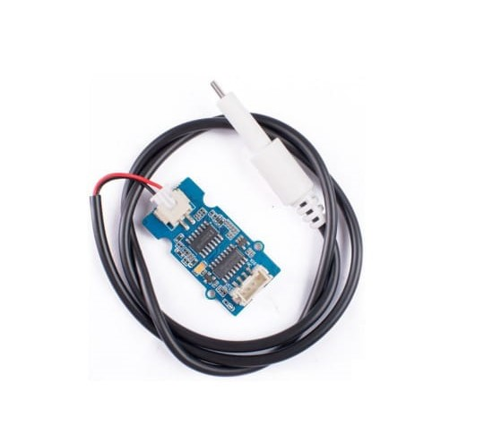

**Fig - 3.1 TDS Sensor**

**Working of TDS sensor**

A TDS sensor's operation is based on the observation that dissolved particles in water conduct electricity. Here is a brief description of a TDS sensor's operation:

1. **Electrical Conductivity**: A modest electrical current is applied between the two electrodes of the TDS sensor when it is submerged in the liquid. The liquid's dissolved particles make it easier for electrical current to flow.

2. **Ion detection**: The TDS sensor detects the ions present in the solution when the current flows through the liquid. Ions are charged particles that are produced when dissolved substances break up.

3. **Measurement**: The electrical conductivity of the liquid, which is inversely correlated with the concentration of dissolved particles, is measured by the TDS sensor. Greater electrical conductivity results from a higher concentration of dissolved solids, which raises the TDS value.

4. **Calibration**: TDS sensors frequently need to be calibrated in order to produce reliable readings. Calibration requires adjusting the sensor values according to the reference solution's known TDS value.

5. **Display and Output**: Digital displays that indicate the measured TDS value in ppm or mg/L are typically included with TDS sensors. For additional analysis and monitoring, some sensors can additionally transfer the data to outside devices or control systems.

It's important to note that TDS sensors provide an estimation of the TDS levels in a solution and do not specifically identify the individual constituents of the dissolved solids. For a comprehensive analysis of water quality, additional testing methods may be required.

### ****3.2 DS18B20 Temperature Sensor :****

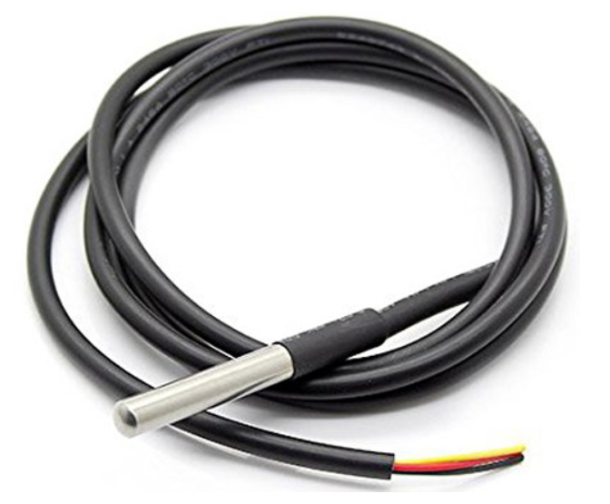

**Fig - 3.2 DS18B20 Temperature Sensor**

A digital temperature sensor, the DS18B20 relies on the idea of temperature-dependent resistance to function. The one-wire communication protocol used by this sensor makes it possible to connect several sensors to a single microcontroller pin.

**Technical Specifications:**

* Temperature range :- (-55 to 125) **°c;**
* **1-Wire interface;**
* **Unique 64-bit address enables multiplexing;**
* **Bit selection resolution :- 9-12 bit;**
* **Accuracy :-** ± 0.5**°c**
* **Operating Voltage :- 3-5 VDC;**
* **Conversion time :- 750ms at 12-bit**

**Pinout of DS18B20 temperature sensor:**

* VCC means - Power input: (3.3 – 5) V DC
* Ground means - Ground pin of the circuit
* Data means - 1 Wire temperature value data output pin

**Working of Temperature Sensor**

A temperature sensor, a digital-to-analog converter (DAC), and a microcontroller make up the DS18B20's fundamental parts. The ambient temperature must be measured and turned into an electrical signal by the temperature sensor. This analogue signal is transformed by the DAC into a digital representation that the microcontroller can understand.

Other temperature sensors like [LM35](https://circuitdigest.com/tags/lm35) or [DHT11](https://circuitdigest.com/tags/dht11) can also be used to measure the temperature but [**DS18B20**](https://circuitdigest.com/tags/ds18b20) is available in a waterproof casing so it is a perfect choice to monitor the temperature of the water. To learn more about **DS18B20**, check our previous project where [DS18B20 is used with Raspberry Pi](https://circuitdigest.com/microcontroller-projects/raspberry-pi-ds18b20-temperature-sensor-interfacing) and [PIC microcontroller](https://circuitdigest.com/microcontroller-projects/pic16f877a-digital-thermometer-using-ds18b20) to build a digital thermometer.

The DS18B20 uses a special operating method called "one-wire communication." This indicates that data transmission and reception just need a single communication line. A daisy-chain configuration, in which numerous sensors are connected in series using a single cable, is how the sensor is intended to be connected.

The microcontroller delivers a reset pulse followed by a presence pulse on the communication line to start communication with the DS18B20 sensor. In order to signal its existence on the bus, the sensor reacts with a presence pulse. When the presence pulse is identified, the microcontroller can start communicating with the sensor and exchanging data.

The sensor receives a command from the microcontroller during temperature measurement telling it to begin the conversion procedure. The DS18B20 then uses an inbuilt sensor to measure the surrounding temperature and transforms it to a digital number. The sensor operates using a method known as "parasitic power," which means it draws energy from the communication connection.

After the conversion is finished, the microcontroller transmits a sequence of read commands and receives the data bits in return to read the digital temperature value from the DS18B20. The sensor sends temperature information bit by bit, holding each bit on the communication channel for a certain amount of time.

The DS18B20 sensor uses a novel technique termed "bit banging" to ensure precise temperature measurements. Each bit that is transmitted on the communication line must be timed exactly in order to do this. The microcontroller can precisely interpret the temperature data from the sensor by carefully managing the time.

In conclusion, the DS18B20 temperature sensor measures temperature using an internal sensor and then transforms the reading into a digital output using a DAC. It uses a one-wire communication protocol, enabling the series connection of several sensors. By carefully timing the transmission of bits on the communication connection, the microcontroller initiates communication, commands the sensor to begin the conversion process, and reads the temperature data. The DS18B20 is an effective and adaptable temperature sensor solution thanks to this distinct methodology.

### ****3.3 What is pH Value?****

The acidity or alkalinity of a solution is determined by the pH value. It determines whether a solution is basic or acidic based on the amount of hydrogen ions (H+) present. The neutral pH value is 7, and the pH scale goes from 0 to 14. A pH value of 7 or above indicates alkalinity, whereas a pH value of 7 or below suggests acidity. Since the pH scale is logarithmic, each unit of acidity or alkalinity corresponds to a tenfold change. A pH metre or pH indicator paper can be used to measure pH. In numerous scientific disciplines, pH is important because it influences chemical reactions, enzyme activity, and the behaviour of substances in solutions.

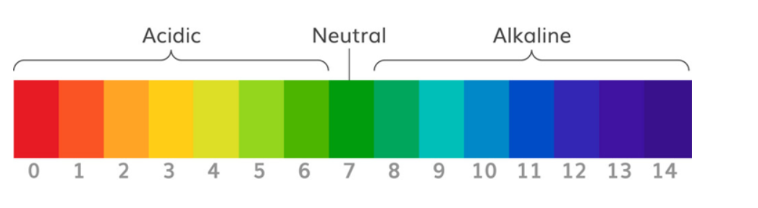

**Fig - 3.3 pH Scale**

### **How Does Gravity Analog pH Sensor work?**

On the basis of sensing the voltage produced by a pH-sensitive electrode, the gravity analogue pH sensor functions. The sensor is made up of a glass electrode that can detect changes in the amount of hydrogen ions present in a solution.

The glass electrode of the pH sensor has a chemical interaction with the hydrogen ions in the solution when submerged. A voltage is produced by this reaction that is inversely proportional to the solution's pH. The voltage is then transformed into an analogue signal that a microcontroller or other electronic devices can measure and interpret.

The pre-calibrated circuit that provides the necessary amplification and conditioning of the voltage signal is commonly used by the gravity analogue pH sensor. This circuit makes sure that the voltage produced from the sensor and the measured pH value match up precisely.

The gravity analogue pH sensor needs to be connected to a data gathering system or compatible microcontroller in order to be used. The microcontroller measures the voltage and translates it into a pH value using a calibration curve or equation unique to the sensor by connecting the analogue output of the sensor to an analogue input pin of the microcontroller.

The gravity analogue pH sensor must be calibrated before use. To establish a connection between the voltage output and the actual pH level, established pH values are compared to the sensor's voltage measurements. The calibration procedure enables the sensor to detect pH with accuracy.

In general, the gravity analogue pH sensor detects the voltage produced by a pH-sensitive glass electrode in response to the concentration of hydrogen ions in a solution. Using calibrating techniques, this voltage is transformed into an analogue signal that can be monitored and analysed to ascertain the pH value of the solution.

**Technical Features:**

**Signal Conversion Module:**

* Supply Voltage: 3.3~5.5V
* BNC Probe Connector
* High Accuracy: ±0.1@25°C
* Detection Range: 0~14

**3.4 pH Electrode:**

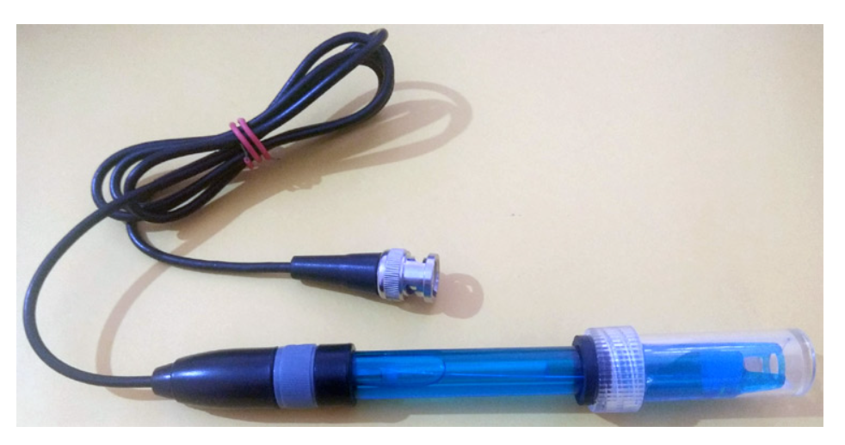

**Fig - 3.4 pH Electrode**

* Operating Temperature Range: 5~60°C
* Zero(Neutral) Point: 7±0.5
* Easy calibration
* Internal Resistance: <250MΩ

**pH Glass Electrode :**

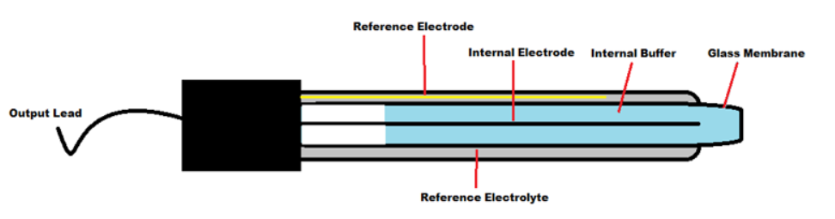

**Fig - 3.5 Construction of pH Electrode**

**The pH electrode, commonly referred to as a pH sensor or pH probe, is an essential element used to determine how acidic or alkaline a solution is. It is made up of a number of essential parts that cooperate to recognise and convert hydrogen ion concentrations into electrical signals.**

**Glass membranes, reference electrodes, and electrolyte solutions are frequently used in pH electrode manufacturing. The main element in charge of detecting pH changes is the glass membrane. It is constructed of a unique kind of glass that only allows hydrogen ions to pass through.**

**A thin, porous layer is typically present on the glass membrane, allowing ions to diffuse through it. Usually, a layer of hydrated gel or a unique polymer is applied to it to improve its reactivity to hydrogen ions. The glass membrane's hydration and sensitivity are preserved by this gel or polymer layer.**

**Another essential component of the pH electrode is the reference electrode. Typically, an electrode made of silver and silver chloride is submerged in an electrolyte solution. The pH-sensitive glass membrane voltage is measured against a steady reference potential provided by the reference electrode.**

**The pH electrode contains the electrolyte solution, sometimes referred to as the internal solution. Usually, a solution of potassium chloride (KCl) or a mixture of KCl and other compounds is used. The electrolyte solution accomplishes two tasks: it helps keep the reference electrode's electrical potential steady and completes the electrical circuit by allowing ions to move between the glass membrane and the reference electrode.**

**The hydrogen ions in the solution can interact with the glass membrane thanks to the pH electrode's structure. A change in ions occurs inside the electrode when it is submerged in a solution because hydrogen ions from the solution permeate through the glass membrane. The voltage potential produced by this ion exchange is related to the solution's pH.**

**A voltmeter or pH metre is used to detect the electrical potential between the reference electrode and the glass membrane in order to determine the pH. The calibration curves or equations specific to the pH electrode being used are then employed to translate this voltage measurement into a pH value.**

**In conclusion, a pH electrode is made up of an electrolyte solution, a reference electrode, and a pH-sensitive glass membrane. The reference electrode offers a stable reference potential, and the glass membrane selectively reacts to hydrogen ions. The electrical potential created by the interaction of the hydrogen ions in the solution with the glass membrane is measured and converted into a pH value using the proper calibration techniques.**

**3.5 pH Signal Conversion Board:**

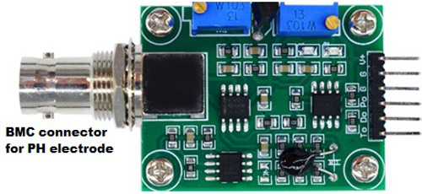

**Fig -3.6 pH Signal Conversion Board**

**Pin Description:**

**V+:** 5V DC input

**G:** Ground pin

**Po:** pH analog output

**Do:** 3.3V DC output

**To:** Temperature output

3.6 **Circuit Diagram**

Circuit diagram for our Arduino based Smart Water Quality Monitoring System is given below:

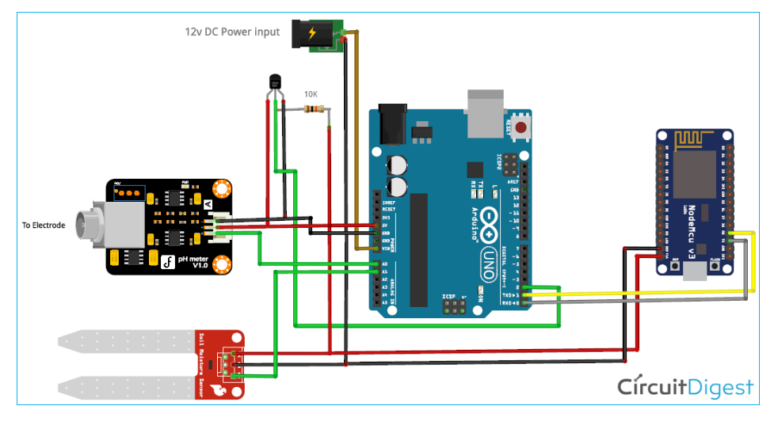

**Fig- 3.7 Circuit diagram**

**Connection of pH Signal Conversion Board with Arduino:**

The connection between Arduino and PH signal conversion board is shown in the table below.

|  |  |
| --- | --- |
| **Arduino** | **pH Sensor board** |
| 5V | V+ |
| GND | G |
| A0 | Po |

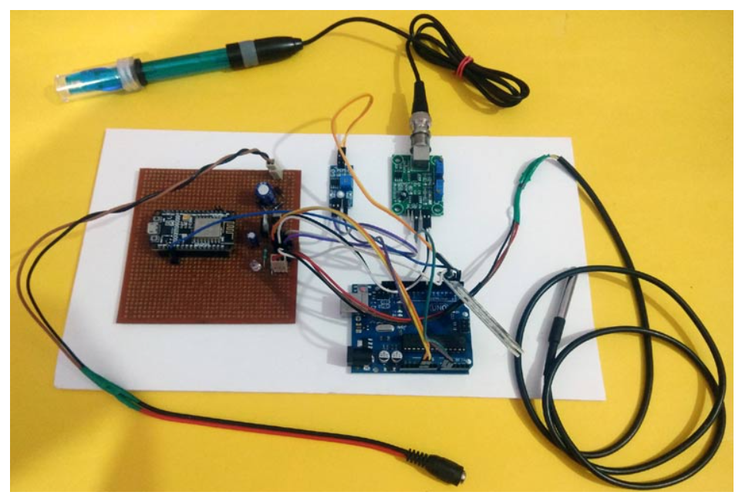

### **Fig - 3.8** Connection of pH Signal Conversion Board with Arduino

### 

### ****3.7 What is Turbidity ?****

When there are suspended particles present in a liquid, such as sediment, bacteria, or other contaminants, the liquid is said to be turbid, which is a measure of the relative clarity or cloudiness of the liquid. It is a crucial factor in many industries, including quality assurance, water treatment, and environmental monitoring. Turbidity sensors are used to measure turbidity precisely. These sensors use various methods to calculate the amount of turbidity in a sample.

### ****Turbidity sensors come in a variety of designs and use various techniques to measure turbidity. Nephelometry and turbidimetry are the two methods that are employed the most frequently.****

### ****1. Nephelometry: Based on the idea of light scattering, nephelometric turbidity sensors measure turbidity. They direct a light beam into the sample and then gauge the brightness of the light that is reflected at a particular angle. The amount of scattered light is inversely correlated with the amount of suspended particles in the liquid. Then, a turbidity value is created from this information using calibration curves or algorithms.****

### ****2. Turbidimetry: On the other hand, turbidimetric turbidity sensors gauge the decrease in light transmission through the sample brought on by the presence of particles. These sensors send out a laser beam through the liquid and measure how much of it reaches the sample's opposite side. The amount of turbidity has a direct impact on how much light is transmitted. A turbidity value is created by calibrating the measured light reduction using calibration curves or algorithms once more.****

### **CHAPTER 04**

### ****Programming for Water Monitoring using IoT****

There are two parts of programming in this Smart Water Monitoring System using IoT. In the first part, Arduino is programmed and in the second part, NodeMCU will be programmed.

**4.1 Arduino Programming:**

const int tdsSensorPin = A0; // Analog input pin for TDS sensor

const int phSensorPin = A0; // Analog input pin for pH sensor

const int referenceResistor = 1000; // Resistance value of the reference resistor (in ohms)

const float tdsFactor = 0.01; // Conversion factor for TDS calculation

void setup() {

Serial.begin(9600); // Initialize the Serial Monitor

Serial.println("TDS and pH Sensor Test");

}

void loop() {

int tdsSensorValue = analogRead(tdsSensorPin); // Read the analog input from the TDS sensor

int phSensorValue = analogRead(phSensorPin); // Read the analog input from the pH sensor

float tdsValue = getTDSValue(tdsSensorValue); // Convert the TDS sensor value to TDS value

float pHValue = getPHValue(phSensorValue); // Convert the pH sensor value to pH value

Serial.print("TDS: ");

Serial.print(tdsValue, 2); // Display TDS value with 2 decimal places

Serial.print(" ppm\t");

Serial.print("pH: ");

Serial.println(pHValue, 2); // Display pH value with 2 decimal places

delay(2000); // Delay for 2 second before next reading

}

float getTDSValue(int tdsSensorValue) {

float voltage = tdsSensorValue * (3.3 / 1023.0); // Convert the TDS sensor value to voltage (NodeMCU operates at 3.3V)

float resistance = ((3.3 - voltage) / voltage) * referenceResistor; // Calculate the resistance based on the voltage

float tdsValue = resistance * tdsFactor; // Calculate the TDS value using the conversion factor

return tdsValue;

}

float getPHValue(int phSensorValue) {

// pH sensor calibration parameters for PH-4502C model

float calibrationOffset = 0.0; // pH offset value

float calibrationSlope = -5.0 / 1023.0; // pH slope value

float voltage = phSensorValue * (3.3 / 1023.0); // Convert the pH sensor value to voltage (NodeMCU operates at 3.3V)

float pHValue = (voltage + calibrationOffset) / calibrationSlope; // Calculate the pH value based on the calibration parameters

return pHValue;

}

### ****4.2 Programming NodeMCU:****

It is now time to program the NodeMCU after successfully completing the hardware setup and Arduino programming.

Note: Before uploading the code, disconnect the Arduino and NodeMCU's Transmitter and Receiver connections.

To transfer code in NodeMCU, follow the means underneath:

1. After starting the Arduino IDE, select File > Preferences > Settings.

2. In the "Additional Board Manager URL" field, enter https://arduino.esp8266.com/stable/package_esp8266com_index.json and select "Ok."

3. Now select Boards Manager from Tools > Board. Type ESP8266 into the search box in

the Boards Manager window, select the most recent board version, and click Install.

1. Select NodeMCU 1.0 (ESP-12E Module) from Tools -> Board -> after installation is finished. The Arduino IDE can now be used to program the NodeMCU.

#define SensorPin 0          // the pH meter Analog output is connected with the Arduino’s Analog

unsigned long int avgValue;  //Store the average value of the sensor feedback

float b;

int buf[10],temp;

void setup()

{

  Serial.begin(9600);

  Serial.println("Ready");    //Test the serial monitor

}

void loop()

{

  for(int i=0;i<10;i++)       //Get 10 sample value from the sensor for smooth the value

  {

    buf[i]=analogRead(SensorPin);

    delay(10);

  }

  for(int i=0;i<9;i++)        //sort the analog from small to large

  {

    for(int j=i+1;j<10;j++)

    {

      if(buf[i]>buf[j])

      {

        temp=buf[i];

        buf[i]=buf[j];

        buf[j]=temp;

      }

    }

  }

  avgValue=0;

  for(int i=2;i<8;i++)                      //take the average value of 6 center sample

  avgValue+=buf[i];

  float phValue=(float)avgValue*5.0/1024/6; //convert the analog into millivolt

  phValue=3.5*phValue;                      //convert the millivolt into pH value

  Serial.print("pH:");

  Serial.println(phValue,2);

  delay(5000);

}

**CHAPTER 05**

**Benefits over traditional methods**

There are a number of advantages that automated water monitoring systems have over traditional manual monitoring techniques. Here are a portion of the key benefits:

1. **Data that is either near or in real time**: Continuous data collection by automated monitoring systems enables real-time or near-real-time monitoring of water quality and quantity parameters. Changes or anomalies in water systems can be quickly detected as a result of this, allowing for prompt responses and mitigation measures.

2. **Improved dependability and accuracy**: When compared to manual sampling and testing, automated sensors and instruments offer greater reliability and accuracy. They dispense with the potential for human mistakes and give steady estimations, guaranteeing solid and exact information.

3. **Early recognition of issues**: By continuously monitoring water parameters, automated systems can quickly identify abnormalities. This capability of early warning enables proactive intervention and problem-solving by promptly identifying potential issues like contamination events, equipment failures, or degradation of water quality.

4. **Cost-effectiveness**: While there may be higher initial costs associated with automated monitoring systems, there may also be savings in the long run. These systems eliminate the need for frequent manual sampling and laboratory testing by automating data collection and analysis. They additionally empower productive portion of assets by focusing on unambiguous regions or periods that require nearer observing.

5. **Effective use of resources**: Mechanized checking frameworks assist with improving the administration of water assets. They work with informed navigation in regards to water designation, dissemination, and preservation endeavors by following boundaries like stream rates, water levels, and use designs. This makes it possible to plan the use of water resources more effectively and sustainably.

**CHAPTER 06**

**CONCLUSION AND FUTURE SCOPE**

Technology advancements and the growing demand for effective and long-term water resource management point to a promising future for automated water monitoring systems.

By connecting various sensors, devices, and data sources, IoT technology has the potential to revolutionize automated water monitoring systems. As a result of this integration, data can be collected, transmitted, and analyzed seamlessly, allowing for a deeper comprehension of water systems.

The vast amounts of data gathered by automated monitoring systems can be processed by AI and ML algorithms, which can then extract useful insights and patterns. These advancements can further develop oddity location, prescient demonstrating, and dynamic capacities.

The capabilities of automated water monitoring systems will be enhanced by the creation of sensors that are more sophisticated and less expensive. The detection of a wider variety of contaminants, the monitoring of microplastics, and the evaluation of the presence of emerging pollutants are all examples of new sensor technologies.

Easy to use points of interaction and information perception instruments will turn out to be progressively significant for mechanized water observing frameworks. Users will be able to easily visualize trends, interpret complex data, and make informed decisions with these systems.

Integration with intelligent water infrastructure will be a part of the future scope of automated water monitoring systems. Leak detection, demand management, and monitoring and management of water distribution networks are all examples of this.

The integration of cutting-edge technologies, data-driven decision-making, and increased stakeholder engagement are the factors that will determine the future of automated water monitoring systems. These frameworks will assume a critical part in tending to water shortage, contamination, and environmental change influences, guaranteeing maintainable water the executives for people in the future.

**REFERENCES**

* [**www.wikipedia.com**](http://www.wikipedia.com)
* [**www.sciencedirect.com**](http://www.sciencedirect.com)
* [**www.pinterest.ph**](http://www.pinterest.ph)
* [**www.quora.com**](http://www.quora.com)
* [**www.waterrf.org**](http://www.waterrf.org)
* **Encyclopedia Britannica**